Mechanistic Modeling of Hollow Fiber Fouling and Sieving Predictions for Continuous Bioprocessing
Ashna Dhingra*, Bioprocess Technologies and Engineering, BioPharmaceuticals Development, R&D, AstraZeneca, Gaithersburg, US
Sungyun Yang, Department of Chemical Engineering, Massachusetts Institute of Technology, Cambridge, US
Devashish Gokhale, Department of Chemical Engineering, Massachusetts Institute of Technology, Cambridge, US
Michael Mollet, Bioprocess Technologies and Engineering, BioPharmaceuticals Development, R&D, AstraZeneca, Gaithersburg, US
Ken Lee, Bioprocess Technologies and Engineering, BioPharmaceuticals Development, R&D, AstraZeneca, Gaithersburg, US
Jon Coffman, Bioprocess Technologies and Engineering, BioPharmaceuticals Development, R&D, AstraZeneca, Gaithersburg, US

*Correspondence: Ashna.dhingra@astrazeneca.com
Abstract
Tangential flow filtration (TFF) is common in bioprocess development for scalable in-line separation, essential to high titer perfusion-scale cultures. Filter fouling due to high-density cell culture and debris causes increased product retention over time and yield loss.
Here we introduce a first-principles mechanistic model that integrates cell growth and death kinetics, fluid mechanics, fouling, and sieving. This model predicts the impact of operational changes, filter geometry, and cell culture performance on the product sieving profile during multi-day perfusion experiments. It also gives insights into dominant fouling mechanisms, membrane usage efficiency, and flux profiles.
This model uniquely calculates the particle production rate by considering both real-time cell density and viability, as well as historical particle-size distribution, enabling the prediction of the fouling profile of a perfusion run without needing any additional filtration performance data at varying cell culture performances.

Starling flow, or flow that passes back from the permeate to the retentate is shown by the model to be a major contributor to filter fouling and therefore product retention. The extent of Starling flow exacerbates axial flux gradients in the fiber which increase fouling and minimize filter area utilization.
A dimensionless scalable value, the back flow ratio, is presented here that can provide an estimate for the extent of Starling flow that a particular membrane is prone to experience. This ratio—flow exiting fibers versus net permeate flow—serves as a tool for hollow fiber evaluation and a precise TFF scaling parameter, replacing net permeate flux for scalability assessments. The back-flow ratio, and thus the rate of fouling, scales with the square of the fiber length, and inversely with the cube of the lumen radius.
BackFutile Flow Ratio=Qstarling,out Qstarling,out -Qstarling,in=Qstarling,out Qp≈ 2μL2QrκR3Qp

Keywords: Tangential Flow Filtration, Continuous Bioprocessing, Mammalian Cell Culture, Filter Fouling, Mechanistic Modeling, Starling Flow, Pore Constriction, Complete Blocking, Intermediate Blocking, Caking, Fluid Mechanics, Sieving

- Introduction
Tangential flow filtration (TFF) is a type of filtration used in continuous processes and is being increasingly used across the industry (Coffman, et al., 2021). A bundled hollow fiber membrane is used as the cell retention device where TFF is the filtration mechanism. In this process, mammalian cell culture from a perfusion bioreactor is pumped into the device and flows tangentially to the surface of a semipermeable or porous membrane, and the filtered permeate is collected. The retentate is then recirculated back into the bioreactor (WuDunn, et al., 2024).

The performance of the TFF is often limited by fouling (Pinto & Brower, 2020). . In perfusion, the main evidence of fouling is often seen by the drop in concentration of antibody or titer in the permeate stream relative to the concentration of titer in the bioreactor. An example of sieving is shown in Figure 2 which shows a decrease in the fraction of product passing through the membrane across different scales for mAb A. The concentration ratio (or sieving ratio) is calculated by dividing the titer concentration in the permeate by the titer concentration in the bioreactor at any given time. Decreases in concentration ratio indicate higher levels of fouling and therefore product retention in the bioreactor.
In order to accurately predict filter fouling, the model presented here accounts for fluid flow , fouling, and sieving The goal of such modeling is the prediction of the concentration/sieving ratio as a function of the cell culture performance, membrane geometry make up, and the bioreactor operating parameters.
Fluid flow is examined through the lens of approximate solutions to the Navier-Stokes equations. The mechanism of membrane fouling is comprised of the four main types commonly used– standard pore constriction/standard blocking, cake filtration, complete blocking, and intermediate blocking (Hermia, 1985) (Kirschner, Cheng, Paul, & Freeman, 2019). We introduce a mathematical formulation to study fouling in detail based on approaches previously used in literature.

- Modeling and Theoretical Aspects
  - Modeling: General Approach
First-principles modeling uses simple mechanistic descriptions to model TFF performance. Although it cannot precisely examine complex geometries and flows, it effectively explains fouling effects. With canonical assumptions like Poiseuille flow in the lumen, the model incorporates particle size effects on TFF performance. It combines first principles and numerical methods to address flow, fouling, and particle size effects. The fouling model uses empirical parameters based on experimental bench-scale data.
The required model inputs are:
- Cell culture performance: In-run viable cell densities (VCD), viabilities, and bleed rates, in addition to particle size distribution for a historic representative run. This information is used to calculate cell kinetics parameters (growth rate, death rate, and particle formation rate) and foulant load and particle size distribution at every time point.
- Membrane geometry makeup: hollow fiber length, lumen diameter, membrane thickness, pore size distribution, fiber count, membrane permeability. This information is used to create flow models which determine flux and pressure profiles which influence fouling models.
- Operating parameters: recirculation rate (or crossflow rate) through hollow fibers, bioreactor volume and VVD. This information is also used to create flow models which determine flux and pressure profiles which influence fouling models.
The primary model output is the sieving ratio profile and pressure profile.

  - Cell Growth Kinetics Model
Membrane fouling occurs due to particles in the fluid, primarily live cells, dead cells, and subcellular debris like DNA, proteins, and lipids. Media components, such as antifoam, are not included in the model, and have not appeared to be a quantitative factor for sieving. One experimental data set for platform cell culture conditions can be used to estimate model parameters for the cell growth model.
(Seamans & Hu, 1990) studied the kinetics of growth and antibody production in a perfusion culture. (Sidoli, Mantalaris, & Asprey, 2004) also proposed a method for the modeling of mammalian cells. Specific cell growth and death rates are generally obtained experimentally, but (Sidoli, Mantalaris, & Asprey, 2004) provided empirical fitting of those parameters with experimental data. The cell growth rate is limited by the maximum apparent growth rate, due to inherent limits associated with the carrying capacity of the reactor. Our kinetic model of cell growth and death also considers the degradation of dead cells into debris, modeling the size distribution of subcellular debris.
Cell Growth Kinetics | Reaction | Exponential Growth Model
Cell Growth | $$C_{v}\underset{→}{μ}C_{v}+C_{v}$$ | $$\frac{dC_{v}}{dt}=μC_{v}-K_{d}C_{v}-\frac{Bleed Rate}{Volume}C_{v}$$
Cell Death | $$C_{v}\underset{→}{K_{d}}C_{d}$$ | $$\frac{dC_{d}}{dt}=K_{d}C_{v}-μ_{3}C_{d}-\frac{Bleed Rate}{Volume}C_{d}$$
Dead Cell Degradation | $$C_{d}\underset{→}{μ_{3}}N×D$$ | $$\frac{dD}{dt}=N_{debris}μ_{3}C_{d}-\frac{Bleed Rate}{Volume}D$$

Table 1. Exponential Cell Growth Kinetics Model.
$$\begin{aligned}μ=μ_{max}^{app}\left(1-α_{capacity}C_{v}\right)\#\left(1\right)\end{aligned}$$
$$\begin{aligned}K_{d}=\left(β_{0}+ β_{1}μ\right)\left(C_{v}+C_{d}\right) \#\left(2\right)\end{aligned}$$
The number factor of cell debris formation (N_{debris}), is estimated to be 10⁶. This is from the volume comparison between dead cells and cell debris from existing data available at AstraZeneca. (Kwon, Yao, Hamel, & Han, 2018).
Once foulant populations are determined, they can be translated into a particle size distribution using measured diameters for live cells, dead cells, and debris. The particle size relative to pore size dictates the fouling mechanism: smaller particles constrict pores, while larger particles can completely block them. (Turner, Joseph, Titchener-Hooker, & Bender, 2017) have studied the size distribution of cell debris at sub-micron and nanometer scale. For specific antibodies, distributions can be found experimentally and fit to a log-normal equation in order to feed the model.

  - Membrane Fouling Modeling
Membranes foul in four ways – standard pore constriction (sometimes referred to as standard blocking), cake formation, complete blocking, and intermediate blocking, as first introduced by Hermia in his study of normal dead-end filtration (Hermia, 1985). These relationships and parameter estimation (only considering standard pore constriction and caking) was shown to be effective at predicting differential pressure profiles for dead-end depth filtration at varying filter areas, scales, and flow rates (Rose, Dhingra, Joseph, & Coffman, 2023). These principles can be extended to TFF as well.
Though these mechanisms were introduced for normal flow filtration, they are easily extended to cross-flow filtration, for instance, as done by (Kirschner, Cheng, Paul, & Freeman, 2019) and (Bolton & Apostolidis, 2017). The equations for the membrane resistance and available area fraction are given by:
$$\begin{aligned}-\frac{∂a_{frac}}{∂t}=σ\left(t\right)a_{frac}\left(t\right)J\left(t\right)-B\left(1-a_{frac}\left(t\right)\right)\#\left(3\right)\end{aligned}$$
$$\begin{aligned}R_{m}\left(t\right)=\frac{R_{m}\left(0\right)}{{\left(1-K_{s}\left(t\right)V_{f}\left(t\right)\right)}^{2}}+K_{c}\left(t\right)V_{f}\left(t\right) \#\left(4\right)\end{aligned}$$
Here, 𝐽 is the flux through the section of the membrane at axial point 𝑧 and time 𝑡, and 𝑉_{𝑓} is the cumulative volume filtered through that section up to time 𝑡. These are obtained over the course of solving the flow and fouling equations in combination with Darcy’s law over time. Area fraction loss rate is a function of currently available area fraction because similar to site-binding theory, the more available area there is, the faster foulant will occupy it. Overall membrane resistance is an additive combination of membrane resistance due to pore constriction and caking, similar to normal flow filtration. Further derivation for standard pore constriction and cake formation fouling mechanisms is outlined by (Rose, Dhingra, Joseph, & Coffman, 2023).
In addition to parameters already described previously, the equations contain the four fouling coefficients – (i) 𝜎, the area blocked through complete and intermediate blocking per volume filtrate, (ii) 𝐵, the liftoff coefficient, which describes the loss of blocking agents from the membrane surface as the particles are carried away by the flow, (iii) 𝐾𝑠, the pore constriction coefficient, and (iv) 𝐾𝑐, the cake resistance coefficient. All four parameters depend on the particle sizes. 𝐵 also depends on the flow rate within the lumen. We solve for σ by integrating over the total areal projection of particles that are larger than the cutoff size for pore entry. Similarly, we solve for 𝐾𝑠 by integrating over the total radius of particles that are smaller than the cutoff size for pore entry.
$$\begin{aligned}σ=c_{1}\int_{r=Kr_{pore}\left(t\right)}^{+∞}{N\left(r,t\right)πr^{2}dr} \#\left(5\right)\end{aligned}$$

$$\begin{aligned}B= \left\{\begin{aligned}c_{2}×\frac{F_{lift}}{F_{drag}}, F_{drag}<F_{lift} \\ c_{2}, F_{drag}≥F_{lift}\end{aligned} \right.\#\left(6\right)\end{aligned}$$

$$\begin{aligned}K_{s}=c_{3}\int_{r=0}^{r=Kr_{pore}\left(t\right)}{N\left(r,t\right)dr} \#\left(7\right)\end{aligned}$$

$$\begin{aligned}K_{c}=c_{4}\left[\frac{α\left(r\right)sρ}{R_{m}\left(t=0\right)\left(1-s\right)}\right] \#\left(8\right)\end{aligned}$$
In these expressions 𝑐₁, 𝑐₂, 𝑐₃, 𝑐₄ are regression parameters which can be solved through parameter estimation with existing sieving ratio data. Additionally, 𝑠 is the volume fraction of solids. 𝐾 describes a fractional cutoff size, separating the particles which are small enough to enter the pore and contribute to standard pore constriction, and those too large to enter pores and must contribute to complete blocking. We also have the specific cake resistance, 𝛼(𝑟), which for slow flow rates can be obtained using the Cozeny-Karman equation. From equation 7, we can see that larger pore sizes will increase the value of K_{s} and therefore increase the contribution of pore constriction. This is why larger pore sizes may in fact result in poorer sieving as seen by (WuDunn, et al., 2024).

  - Flow Model
For the fiber types and recirculation rates used for perfusion TFF described here, the flow inside the lumen was determined to be nearly laminar through Reynolds number calculations. Time-independent flow was also assumed given that the fouling time scale is much larger than the flow time scale. Since the permeate flow rate is much smaller than the recirculation rate, we can assume that the flow in the lumen is fully developed. The pressure drop is also assumed to be only variant axially in the z-direction and not in r. All of these assumptions can be used to analytically simplify the Navier-Stokes equations, so that the flow inside the lumen can be treated as Hagen-Poiseuille flow.
$$\begin{aligned}\frac{dP}{dz}=-\frac{8μu\left(z\right)}{R^{2}} \#\left(9\right)\end{aligned}$$
The lumen flow model demonstrates the variation in pressure along the axis of the lumen. This, in turn, causes the transmembrane pressure (TMP) to vary spatially, which results in a spatial variation in flux and fouling. The fiber was discretized into a number of smaller partitions in series to numerically account for these variations. This mathematical setup is shown in Figure 2.
Using continuity and shell balances around each partition and Darcy’s law, we arrive at:
$$\begin{aligned}\frac{du}{dz}=-\frac{2κ\left(z\right)}{R}\left[P\left(z\right)-P_{permeate}\right] \#\left(10\right)\end{aligned}$$
$$\begin{aligned}J\left(t,z\right)=κ\left(t,z\right)×\left[P\left(t,z\right)-P_{permeate}\left(t\right)\right]\#\left(11\right)\end{aligned}$$
Here, $κ$ is the membrane permeability which is a function of time and axial position because of fouling, and J is the flux of permeate exiting the fibers.
Combining equations 9 and 10 above, we get the following second order ordinary differential equation (ODE) which can be solved numerically (or analytically in the absence of fouling):
$$\begin{aligned}\frac{d^{2}P}{dz^{2}}=\frac{16μκ\left(t,z\right)}{R^{3}}\left(P\left(t,z\right)-P_{permeate}\left(t\right)\right)\#\left(12\right)\end{aligned}$$

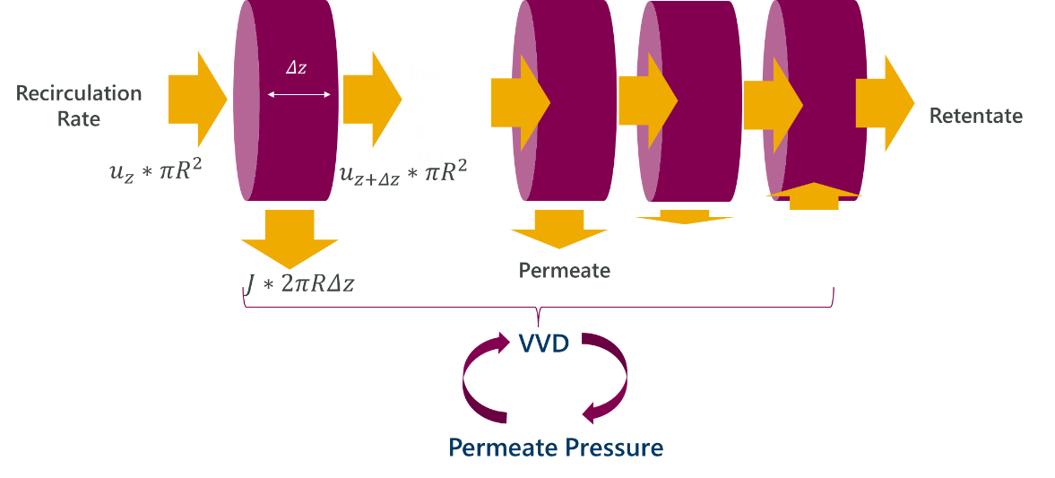
Figure 1. Serial Filtration Modeling Approach: Discretized Fiber.
Boundary condition is as follows:
$$\begin{aligned}u\left(z= 0\right)=u_{0}=\frac{Q_{r}(z=0)}{N_{fibers}πR^{2}}\#\left(13\right)\end{aligned}$$
In constant permeate flow operation, 𝑄𝑝 is a set constant in the model and the above equations are solved iteratively through error minimization to calculate $P_{permeate}$. Equation 14 is used as the objective function for error minimization.
$$\begin{aligned}Q_{p}= \left(u\left(z= 0\right)-u\left(z=L\right)\right)×πR^{2}N_{fibers}\#\left(14\right)\end{aligned}$$
In the absence of fouling, at the initial time point, i.e. constant $κ,$ equation 12 has an analytical solution, outlined in equations 15 and 16:
$$\begin{aligned}P\left(z, t=0\right)=P\left(z=0\right)-\left[\sqrt{\frac{4μu_{0}^{2}}{κR}}Sinh\left(\sqrt{\frac{16μκ}{R^{3}}}z\right)+\frac{8μκ}{R^{3}}P_{permeate}z^{2} \right]\#\left(15\right)\end{aligned}$$

$$\begin{aligned}P_{permeate}=P(z=0)-\frac{R}{2Lκ}\left[\frac{Q_{p}}{N_{fibers}πR^{2}}- u_{0}Cosh\left(\sqrt{\frac{16μκ}{R^{3}}}L\right)+u_{0} \right]\#\left(16\right)\end{aligned}$$
The flow through the membrane in each partition is given by Darcy’s law:
Qp,zz,t= ΔPz,tamz,tμRmz,t=κz,tΔPz,t×2πRamz,t#13
Here, ΔP is the local TMP within each submodule, $a_{m}$ is the local unfouled membrane area, and $R_{m}$ is the local membrane resistance which is inverselyrelated to permeability. The total flow through the membrane (permeate flow) is given by the following equation which is integrated numerically:
$$\begin{aligned}Q_{p}=\int_{z=0}^{z=L}{\frac{ΔP\left(z,t\right)a_{frac}\left(z,t\right)}{μR_{m}\left(z,t\right)}}2πRN_{fibers}dz \#\left(14\right)\end{aligned}$$
  - Sieving Model
The membrane pore diameter reduces over time as the pores foul due to standard pore constriction. When the pore size is similar or smaller than the product size, the transport of product through the pore stops. Bolton et al. describe the canonical approach, which is to introduce a sieving coefficient, 𝑆 (Bolton & Apostolidis, 2017). The sieving coefficient varies spatially and temporally since membrane pore size varies as such.
$$\begin{aligned}S\left(z,t\right)= \frac{c_{permeate}\left(z,t\right)}{c_{lumen}\left(z,t\right)}=\frac{W}{1-\left(1-W\right)\exp\left(-\frac{WL_{m}J}{HD}\right)} \#\left(15\right)\end{aligned}$$
Here, 𝑊 is a diffusive hindrance coefficient, 𝐻 is the convective hindrance coefficient, 𝐿_{m} is the pore length (membrane thickness), and 𝐷 is the product diffusion coefficient. Diffusion cofficients are all in units of m²/s. These are both functions of λ, which is the ratio of product radius and pore radius at any given time and axial point. It is useful to consider the dependence of product radius and product diffusion coefficient on the molecular weight of the protein. From literature, (Young, Carroad, & Bell, 1980) (Erickson, 2009), the following correlations are useful:
$$\begin{aligned}D=8.34×{10}^{-15}\left(\frac{T}{μ}\right)M^{-\frac{1}{3}} \#\left(16\right)\end{aligned}$$
$$\begin{aligned}radius=6.6×{10}^{-11}M^{\frac{1}{3}} \#\left(17\right)\end{aligned}$$
𝑇 is the temperature in Kelvin, and 𝑀 is the molecular weight in Da.
  - Combining Models
Spatial averaging is used to calculate the net concentration in the permeate. The outward molar flow rate can be calculated as:
$$\begin{aligned}F_{p}\left(z\right)=J\left(z\right)S\left(z\right)c\left(z\right)a_{m} \#\left(16\right)\end{aligned}$$
By mass balance, the concentration in the lumen in the next submodule is:
$$\begin{aligned}c\left(z+dz\right)= \frac{Q_{r}\left(z\right)c\left(z\right)-F_{p}\left(z\right)}{Q_{r}\left(z+dz\right)} \#\left(18\right)\end{aligned}$$
Let 𝑐(0)=1, which is equivalent to using the inlet concentration as the baseline, and the permeate concentration obtained will be in multiples of the inlet concentration. The above equations can be solved numerically, piecewise to obtain 𝑐(𝑧) in the lumen and 𝐹_{𝑝}(𝑧) along the membrane. The total molar flow rate coming out of the membrane is the summation of the 𝐹_{𝑝} values, and the permeate concentration is the ratio of the molar flow rate to the volumetric flow rate.
$$\begin{aligned}c_{p}=\frac{1}{Q_{p}}×\frac{1}{L}\int_{z=0}^{z=L}{F_{p}\left(z\right)dz} \#\left(19\right)\end{aligned}$$
- Materials and Methods
The model was programmed in MATLAB. Time discretization was chosen to be 10,000 seconds since the fouling time scale is on the order of days. The program iterates through the model at each time point using a “for” loop. Error minimization is performed using MATLAB functions “fmincon” and “fsolve”. Coupled ODEs are solved using “ode45” which uses variable step sizes to compute solutions. Definite integrals (equations 5, 7, 14, and 19) are approximated as summations using a partition size much less than the length of the fiber. The analyses shown in this paper use a partition size of 1cm.
Parameter estimation was performed using historic 3L experimental data from the platform mAb A (n = 5) in order to obtain values for c1, c2, c3, and c4 referenced in equations 5 - 8.
  - Experimental Conditions
Model validation was performed at four scales of perfusion: ambr250, 3L, 50L, and 500L with mAb A. This mAb was used extensively for technology development of AstraZeneca’s perfusion platform. Parameter estimation for cell kinetics and filter fouling parameters was performed once using five 3L scale platform experiments, and predictions at the various scales with unseen sieving ratio data is shown below in Figure 3. Corresponding experimental conditions are outlined in Table 2. Wall shear rate is calculated using the same equation used by (WuDunn, et al., 2024) in their study (equation 3).
Scale | Filter Model | Bioreactor Working Volume | Recirculation Rate, $Q_{r}(z=0)$  (Shear Rate) | Permeate Target Flux (LMH)
Ambr250 | Repligen (part # T02-P20U-10-N) | 240mL | 70 mL/min  (848 1/s) | 1.4
3L | Repligen (part # S04-P20U-10-N) | 2L | 268 mL/min  (607 1/s) | 1.0
50L | Repligen (part # K06-P20U-10-N) | 40L | 5 LPM  (679 1/s) | 0.8
500L | Repligen (part # X06-P20U-10-N) | 220L | 15 LPM  (760 1/s) | 1.7

Table 2. Perfusion experimental conditions at each scale with mAb A. Exchange rate for all scales was 1.2 VVD, and bleed target for all scales was 90e6 cells/mL. Note: These were platform conditions at the time this work was completed. Corresponding sieving ratio data and model performance are shown in Figure 3.
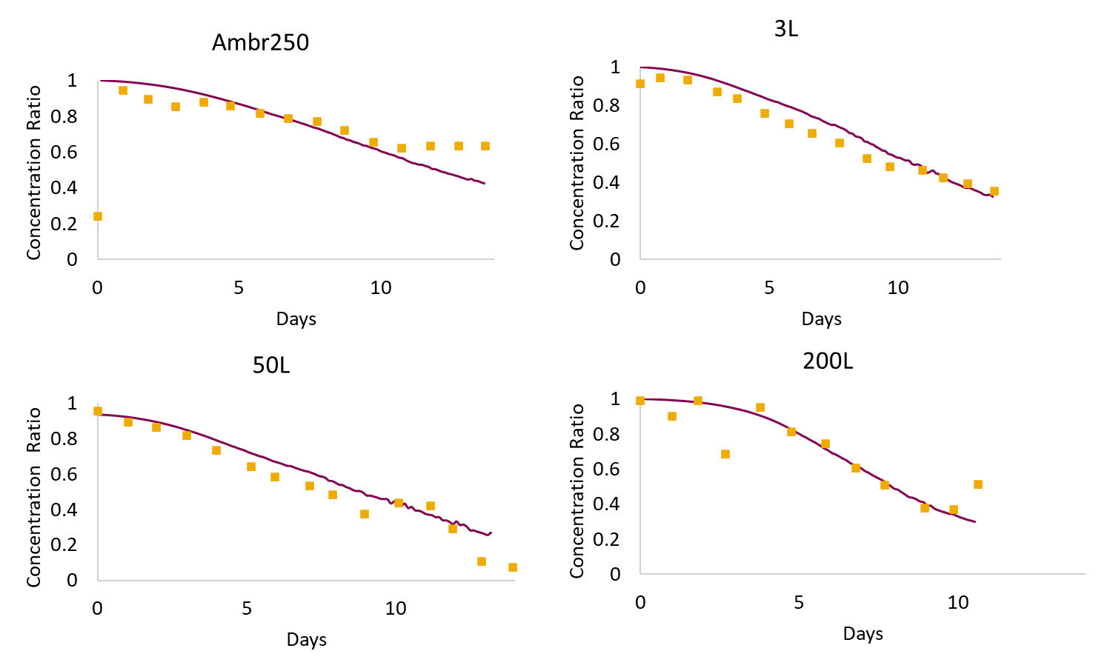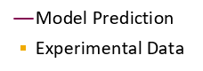
Figure 2. Model Validation Across Scales showing test set data. (Experimental data is unseen by model).
The model was able to quantify differences in sieving ratio profiles between scales and attribute them to differences such as cell culture viability profiles and filter geometries.

- Results and Discussion
This model was used extensively in optimizing and guiding experimentation to reduce product retention in AstraZeneca’s perfusion platform and is currently being used to inform scale up for commercial implementation. The model enabled a better mechanistic understanding of physical phenomena occurring within the hollow fiber.
  - Effect of Filter Geometry: Starling Flow
The model highlighted that filter geometry significantly affects product retention due to Starling flow (or back flow) resulting from non-uniform pressure and flux profiles (WuDunn, et al., 2024). This intensifies fouling and limits filter area use as flux varies axially, with higher fluxes causing more fouling (Figure 3A). Therefore, net permeate flux and filter capacity alone are not reliable scaling parameters. Elevated Starling flow also leads to a cell concentration gradient along the fiber length. As fluid is leaving the fibers to the permeate side, the axial recirculation rate drops therefore concentrating the cells until TMP reaches zero. The cells are then reconcentrated during back-flow. This is shown visually in Figure 3B for 3L platform conditions (Table 2) with an unfouled Repligen filter at a culture viscosity of 1cP.
A.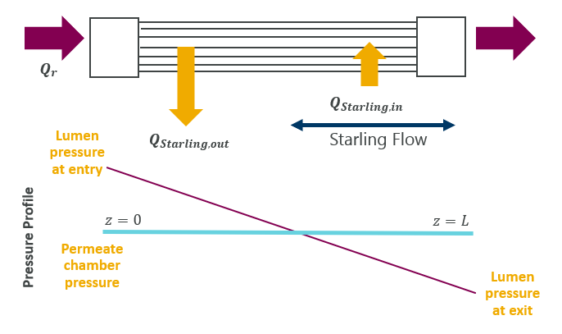B. 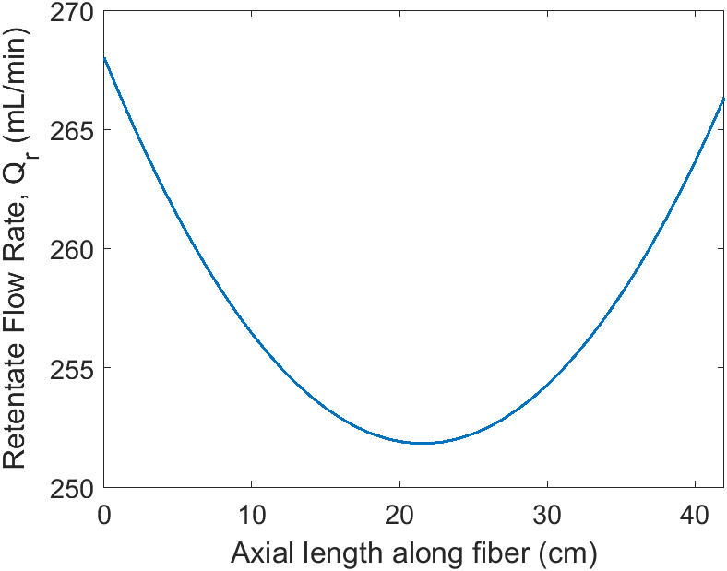
Figure 3. Visualization of Starling flow in a hollow fiber membrane (A) and retentate flow rate as a function of axial position along an unfouled fiber length with 3L platform conditions outlined in Table 2 with a cell culture viscosity of 1 cP (B).
  - Scalable Parameter to Predict Starling Flow: Back Flow Ratio
The flow model (described above in Section 2.4) is able to solve for the lumen pressure profile and $P_{permeate}$ at each time point through error minimization by discretizing the fiber and using the pressure and velocity ODEs. It can then calculate the flow rate exiting the fibers through each discretization. We can use this to assess the extent of Starling flow compared to net permeate flow. We can collapse these equations into a simplified algebraic equation by making the assumptions below.
In most ranges of Starling flow and at $t=0$ (no fouling), we can say that:
- The pressure profile between z = 0 and z = L is linear.
This assumption only breaks down in the limit of very high Starling flow. The pressure drop across the length of the filter is given by the Hagen-Poiseuille equation (equation 9). The flux range across the length of the fiber can then be expressed using Darcy’s Law:
Jz=0-Jz=L= 8μLQrκNfibersπR4 (19)
From this we can determine that the point at which Starling flow occurs, i.e. where flux is zero can be expressed as:
zJ=0=Qp2πRN×(Jz=0-Jz=L)+L2=QpR316μLQrκ+L2 (20)
If there is no Starling flow, then $z_{J=0}$= L.
Therefore, the flux profile as a function of axial distance can be expressed as:
Jz= 8μQrκNfibersπR4zJ=0-z (21)
A dimensionless ratio, the back flow ratio (BFR₁), can then be derived as noted below. It expresses the ratio between flow rate exiting the fibers into the permeate shell and the actual net permeate flow rate at time = 0 in the absence of fouling.
Qstarling,outz=2πRN0zJ=08μQrκNfibersπR4(zJ=0-z)dz (22)
BFR1=Qstarling,out Qstarling,out -Qstarling,in=Qstarling,out Qp≈ 2μL2QrκR3Qp+QpR332μL2Qrκ+12 (23)
This dimensionless number can be used as tool for primary screening of hollow fibers as well as a scaling parameter prior to any cell culture testing without having to use the full MATLAB flow model.
We can further simplify this expression in the case where there significant enough Starling flow such that:
- $z_{J=0}≈\frac{L}{2}$
In this case, BFR₁ further simplifies to:
BFR2=Qstarling,out Qstarling,out -Qstarling,in=Qstarling,out Qp≈ 2μL2QrκR3Qp (24)
Assumption 2 says that flow is reversed roughly halfway down the length of the fiber. This assumption breaks down in the limit of low Starling flows.
Backflow ratios significantly greater than 1 (BFR >> 1) indicate high Starling flow, resulting in poor membrane utilization and a higher risk of reduced filter capacity (L/m²). Figure 5 illustrates pressure profiles for different BFR values. To mitigate Starling flow, consider increasing permeate flow (net filter fluxes), reducing axial pressure drop, or employing membranes with lower permeability. Axial pressure drop can be lowered by reducing fiber length, recirculation rate, or by increasing lumen radius.
The results of these assumptions can be seen in Figure 4 below where we solved for the actual ratio using the full flow ODE model in MATLAB and equation-estimated ratios, BFR1 and BFR2. This analysis varies all 6 parameters in the back flow ratio.
A. 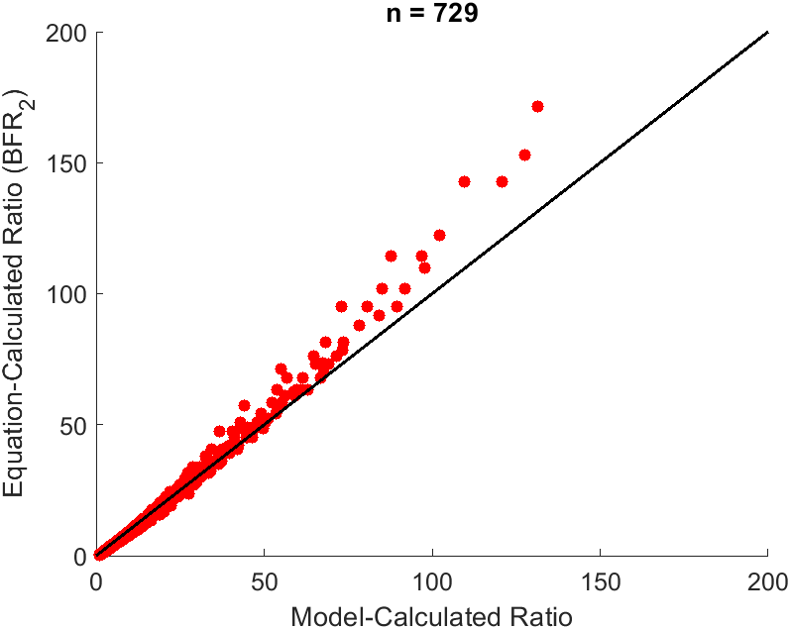 B. 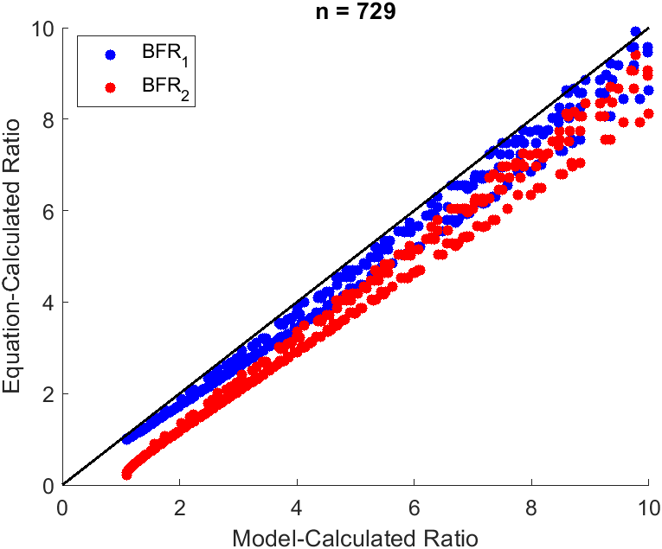
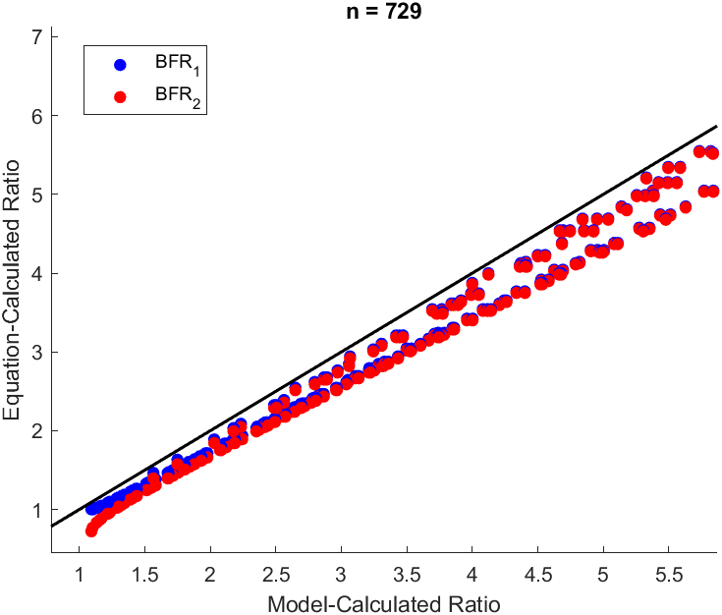

Figure 4. A. Back Flow Ratio as Calculated by Approximated Equation (BFR2) vs. Fluid Flow MATLAB model. B. Back Flow Ratio as Calculated by Approximated Equation (BFR1 and BFR2) vs. Fluid Flow MATLAB model (zoomed in). Values were chosen around 3L scale Repligen platform values.
The model trend follows the dimensionless number estimation very closely, and we can see that BFR1 is more accurate than BFR2 at lower ratios where BFR2 underestimates Starling flow. The equation can be used to assess relative impact of Starling flow when considering hollow fibers from different vendors, with different geometry and membrane chemistry make-up, and also when scaling up from bench scale bioreactors. This analysis is performed in section 4.4 below using experimental data collected at AstraZeneca.
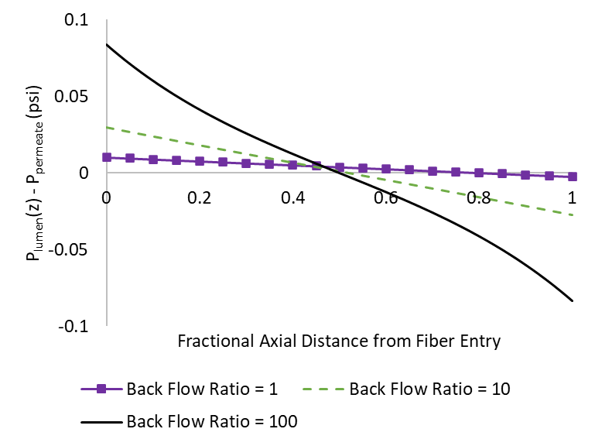
Figure 5. Model-calculated TMP as a function of fractional distance from fiber entry for different Back Flow Ratio values.
Membrane permeability, κ, will drop over the course of an experiment as a function of axial length as fouling occurs so the impact of Starling flow will decrease. If the permeability drops too low, then permeate flow rate can no longer be maintained.
  - Analyzing Flux Profiles Within the Fiber
The model can calculate temporally and axially varying flux profiles in the presence of fouling. Figure 6A illustrates modeled flux through fibers in a 3L platform perfusion experiment. Positive values signify flow from lumen to permeate side, and negative values signify flow from permeate to lumen side. At time point 0 (depicted by the yellow trend in Figure 6), there is no fouling so the pressure profile within the lumen has a near-constant slope, and membrane area utilization is around 50%. As fouling increases, resistance rises, reducing flux at fiber entry. To maintain permeate flow, permeate pressure decreases, accessing more membrane area; by day 12, 70% is utilized. The area under each of those three curves is equivalent since the permeate flow rate is maintained. Since flux gradients cause uneven fouling, the model calculates the average pore radius and available area fraction as a function of axial position (Figure 6B and Figure 6C).
Because of Starling flow, filter capacity does not scale proportionally with net permeate flux targets. For example, although the permeate flux target may be 1 LMH for the 3L scale, the distribution is variable along the fiber length and can go up to 40 LMH as shown in Figure 6D. Moreover, doubling the target permeate flux from 1 LMH to 2 LMH will result in more filter capacity (L/m²) at 2 LMH. This is because while the net permeate flux is doubling, the flux that the fibers experience at any axial point only increases marginally. Net flux is the difference between the positive flow exiting the fibers and the negative flow back into the fibers. The fluxes are already so large that the permeate pressure only has to decrease slightly in order to maintain a higher permeate flow rate, shown in Figure 6D.
(WuDunn, et al., 2024) have shown this pattern experimentally as well with AstraZeneca’s platform mAb A at the 3L scale. In the case of Repligen at 1 LMH (S04-P20U-10-N) and at 5.5 LMH (T04-P20U-10-N), the latter showed more than 3x improvement in filter capacity (L/m²) at a sieving ratio of 0.5.
This phenomena and subsequent analysis suggest that target permeate flux is not necessarily an accurate scaling parameter when scaling from bench scale to larger scale reactors or even when comparing different hollow fibers.
A. 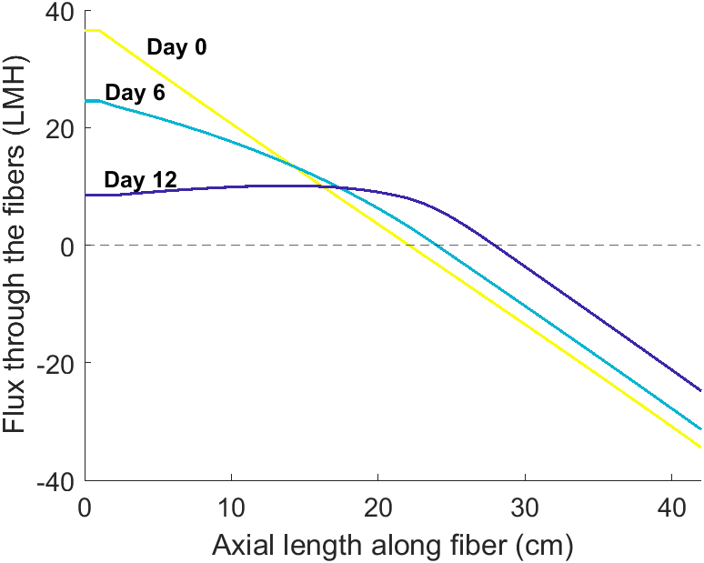 B. 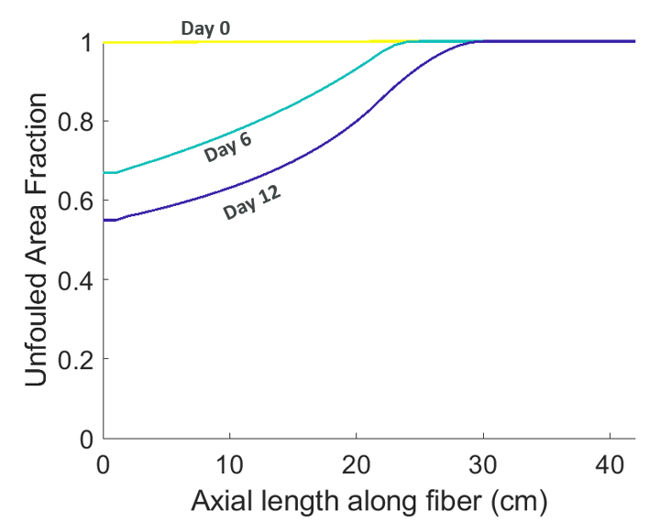
C. 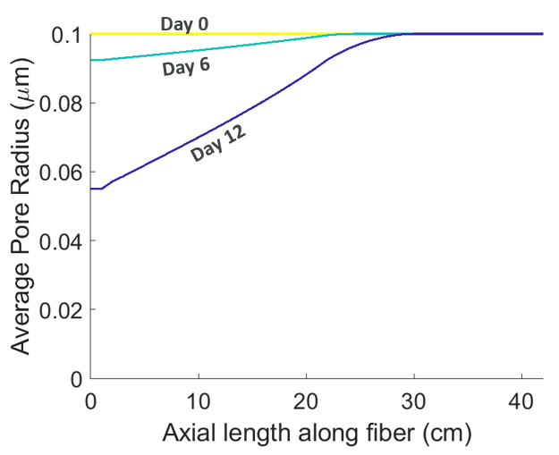D. 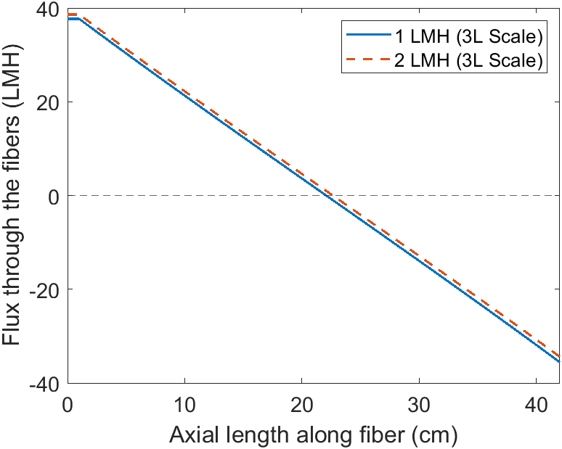
Figure 6 Model-Generated Temporally and Spatially Varying Flux Profiles (A) Unfouled Area Fraction (B), and Average Pore Radius (C) at 3L Platform Conditions at 1 LMH with Repligen fibers. Model-Generated Flux Profiles at Day 0 (unfouled fiber) at 3L Platform Conditions at permeate targets of 1 and 2 LMH (D). Conditions at 1 LMH correspond to a pre-fouling back flow ratio of 9.5 (equation-approximation), and conditions at 2 LMH correspond to a pre-fouling back flow ratio of 4.3 (equation-approximation).
  - Comparing the Back Flow Ratio to Experimental Results
Experiments conducted by (WuDunn, et al., 2024) and (Vu, Gadberry, Coffman, & Lee, 2024) along with additional experimentation carried out at AstraZeneca using platform mAb A span a range of back flow ratios. The back flow ratio (for an unfouled filter) was calculated for each fiber type and operation condition. This was then compared to the permeate throughput per fiber area (L/m²) at 50% sieving. Viscosity was taken to be an approximate inoculation viscosity of 1 cP as determined experimentally with cell culture samples. Membrane permeabilities for the Asahi Kasei fibers were retrieved from the work of Pinto et al. (Pinto & Brower, 2020). For the remaining fibers, natural flux water testing was performed at AstraZeneca following the same methodology used by (Pinto & Brower, 2020) to calculate membrane permeabilities. Results are shown in Table 2 and below. Each row represents a different bioreactor and experiment with varying cell culture performances which would not be captured in the back flow ratio. As discussed previously, cell culture performance has an effect on sieving profiles which causes the variability in permeate throughput at operationally-equivalent conditions.

 | Area (m2) | Net Permeate Flux (LMH) | Experimental Permeate Throughput at 50% Sieving (L/m2) | Length (cm) | Lumen ID (mm) | Bioreactor Volume (L) | Experimental Permeability (LMH/psi) | Recirculation Shear Rate (s⁻¹) | Back Flow Ratio – Equation Approximation (BFR2) | Back Flow Ratio – ODE Model Calculation
Repligen, 0.2 µm, PES | 0.018 | 5.5 | 658 | 41.5 | 1.0 | 2.0 | 530 | 606 | 1.8 | 2.4
 | 0.018 | 5.5 | 707 | 41.5 | 1.0 | 2.0 | 530 | 606 | 1.8 | 2.4
Repligen, 0.2 µm, PES | 0.098 | 1.0 | 212 | 41.5 | 1.0 | 2.0 | 530 | 607 | 9.5 | 11
 | 0.098 | 1.0 | 219 | 41.5 | 1.0 | 2.0 | 530 | 607 | 9.5 | 11
Repligen, 0.2 µm, PES | 0.098 | 1.0 | 136 | 41.5 | 1.0 | 2.0 | 530 | 1360 | 21 | 23
 | 0.098 | 1.0 | 148 | 41.5 | 1.0 | 2.0 | 530 | 1360 | 21 | 23
 | 0.098 | 1.0 | 137 | 41.5 | 1.0 | 2.0 | 530 | 1360 | 21 | 23
Repligen, 0.2 µm, PES | 0.098 | 2.0 | 352 | 41.5 | 1.0 | 2.0 | 530 | 607 | 4.7 | 5.6
 | 0.098 | 2.0 | 516 | 41.5 | 1.0 | 2.0 | 530 | 607 | 4.7 | 5.6
 | 0.098 | 2.0 | 457 | 41.5 | 1.0 | 2.0 | 530 | 607 | 4.7 | 5.6
 | 0.098 | 2.0 | 444 | 41.5 | 1.0 | 2.0 | 530 | 607 | 4.7 | 5.6
 | 0.098 | 2.0 | 481 | 41.5 | 1.0 | 2.0 | 530 | 607 | 4.7 | 5.6
Repligen, 0.2 µm, PES | 2.55 | 0.8 | 144 | 65 | 1.0 | 40 | 530 | 543 | 17 | 17
Repligen, 0.2 µm, PES | 0.79 | 0.8 | 269 | 20 | 1.0 | 40 | 530 | 679 | 6.1 | 7.8
Repligen, 0.2 µm, PES | 7.16 | 1.5 | 286 | 68 | 1.0 | 220 | 530 | 760 | 13 | 13
Asahi, 0.2 µm, PVDF | 0.02 | 5.5 | 1046 | 19.8 | 1.4 | 2.2 | 111 | 606 | 0.11 | 1.1
 | 0.02 | 5.5 | 880 | 19.8 | 1.4 | 2.2 | 111 | 606 | 0.54 | 1.3
Asahi, 0.65 µm, PVDF | 0.02 | 5.5 | 1062 | 19.8 | 1.1 | 2.2 | 410 | 605 | 0.54 | 1.3
 | 0.02 | 5.5 | 1086 | 19.8 | 1.1 | 2.2 | 410 | 605 | 0.54 | 1.3
Asahi, 0.2 µm, PVDF | 0.02 | 5.5 | 927 | 19.8 | 1.4 | 2.2 | 111 | 607 | 0.11 | 1.1
 | 0.02 | 5.5 | 1015 | 19.8 | 1.4 | 2.2 | 111 | 607 | 0.11 | 1.1
Sartorius, 0.2 µm, mPES | 0.0155 | 5.5 | 713 | 27.3 | 1.0 | 1.7 | 1573 | 604 | 3.4 | 4.1
 | 0.0155 | 5.5 | 691 | 27.3 | 1.0 | 1.7 | 1573 | 604 | 3.4 | 4.1
Sartorius, 0.2 µm, mPES | 0.0155 | 5.5 | 841 | 27.3 | 2.0 | 1.7 | 1274 | 606 | 1.2 | 1.9
 | 0.0155 | 5.5 | 828 | 27.3 | 2.0 | 1.7 | 1274 | 606 | 1.2 | 1.9
Sartorius, 0.65 µm, mPES | 0.0155 | 5.5 | 837 | 27.3 | 1.0 | 1.7 | 1597 | 604 | 3.5 | 4.2
 | 0.0155 | 5.5 | 831 | 27.3 | 1.0 | 1.7 | 1597 | 604 | 3.5 | 4.2
Sartorius, 0.2 µm, mPES | 0.0155 | 5.5 | 833 | 27.3 | 1.0 | 1.7 | 1573 | 604 | 3.4 | 4.1
 | 0.0155 | 5.5 | 767 | 27.3 | 1.0 | 1.7 | 1573 | 604 | 3.4 | 4.1

Table 3. Equation-calculated and model-calculated back flow ratios compared to experimental conditions tested at AstraZeneca. Each row represents a different bioreactor and experiment. The variability seen in throughput at equivalent conditions shows how variability in cell culture performance and experimental variability can influence filter performance. Experimental data retrieved from WuDunn et al and Vu et al (WuDunn, et al., 2024) (Vu, Gadberry, Coffman, & Lee, 2024).
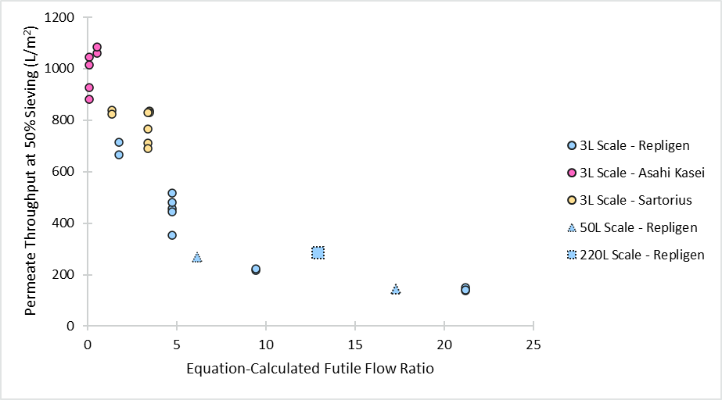
Figure 7.Permeate volumetric throughput at 50% sieving vs. calculated back flow ratio (BFR2). This is a graphical representation of the calculations presented in Table 2. The dimensionless number Back Flow Ratio has a strong correlation with the capacity of a TFF perfusion system as indicated by the throughput at which sieving decreases to 50%. Correlation coefficient = 0.81.
These results show a clear correlation between throughput and back flow ratio values for three different scales, three different filter vendors and membrane chemistries, and a range of fiber dimensions. Per theoretical predictions outlined in section 4.3, higher back flow ratios generally result in lower permeate throughput. The correlation coefficient between the back flow ratio and the permeate throughput at 50% sieving for the above data set is 0.81.

- Conclusion
As the industry shifts towards high-titer perfusion culture, designing and scaling TFF membranes is vital. The mechanistic model presented here includes phenomena like cell kinetics, fluid mechanics, and fouling mechanisms to predict sieving across scales and fiber types. It accounts for pore constriction, blocking, and caking. Parameters were estimated with AstraZeneca mAb A and Repligen hollow fibers at 3L scale, with proven accuracy from ambr250 to 500L.
Starling flow, a major contributor to fouling and inefficient membrane use, especially with large pressure drops, occurs when the TMP is negative, causing reverse flow into the lumen. As a result, filter capacity doesn't scale proportionally with permeate flux targets, due to varying flux along the fiber.
Sensitivity analyses found that shorter fibers, larger lumen diameters, lower recirculation rates, lower membrane permeability, smaller pore sizes, higher cell viability, lower cell culture visocisty, and lower cell density enhance filter capacity. A derived dimensionless backflow ratio (correlation coefficient = 0.81) indicates Starling flow impact and membrane use efficiency. High values suggest poor efficiency and lower throughput. The ratio helps design fibers less prone to Starling flow, aiding AstraZeneca's scale-up of TFF systems for larger processes.

- Acknowledgements
This study was supported by AstraZeneca. The authors would like to thank Bioprocess Technologies & Engineering Upstream, Bioprocess Technologies & Engineering Commercial Scale Implementation, Scale Up Lab, Development Scale-Up Center, and Cell Culture and Fermentation Sciences, within BioPharmaceuticals Development at AstraZeneca. The authors would additionally like to thank the following individuals at AstraZeneca for their experimental and theoretical contributions: Thomas Blacklock, Samik Das, Ana Di Lillo, Carrington Edmunds, J. Alex Gadberry, Nicholas Guros, Adrian Joseph, Samuel Preza, Steven Rose, Zayla Schaeffer, Andrea Squeri, Jimmy Vu, and Dominique WuDunn.
All authors have competing interest due to affiliation with AstraZeneca. All authors except SY and DG were employees of AstraZeneca at the time this work was performed and may hold stock ownership or stock interests in the company. SY and DG participated in this work as part of the Practice School Program in collaboration with the Massachusetts Institute of Technology (MIT).
- Nomenclature

Nomenclature
$$a_{frac}$$ | Available, unfouled area fraction in an axial partition
$$a_{m}$$ | Available, unfouled area in an axial partition (m²)
$$B$$ | Liftoff coefficient (1/s)
$$c_{1},c_{2},c_{3},c_{4}$$ | Regression parameters
$$C_{v}$$ | Viable cell density in culture (cells/mL)
$$C_{d}$$ | Dead cell density in culture (cells/mL)
$$c$$ | Product concentration in the fibers (mol/m³)
$$c_{p}$$ | Product concentration in the permeate (mol/m³)
$$D$$ | Product diffusivity (m²/s)
$$F_{drag}$$ | Drag force on a particle (N)
$$F_{lift}$$ | Life force on a particle (N)
$$F_{p}$$ | Molar flow rate of product through the fiber (mol/s)
$$H$$ | Convective hindrance coefficient
$$J$$ | Flux through the membrane (m/s)
$$K$$ | Pore radius cutoff fraction
$$K_{c}$$ | Caking coefficient
$$K_{s}$$ | Standard pore constriction coefficient
$$L$$ | Fiber length (m)
$$L_{m}$$ | Membrane thickness (m)
$$M$$ | Product mass (Da)
$$N$$ | Concentration of particles including live cells, dead cells, and debris
$$N_{debris}$$ | Number of debris particles formed from the decay of a single dead cell
$$N_{fibers}$$ | Number of hollow fibers in a single TFF module
$$P$$ | Pressure in lumen (Pa)
$$P_{permeate}$$ | Permeate pressure (Pa)
$$ΔP$$ | TMP (Pa)
$$Q_{p}$$ | Permeate flow rate (m³/s)
$$Q_{r}$$ | Retentate/Recirculation flow rate (m³/s)
$$R$$ | Lumen radius (m)
$$R_{m}$$ | Membrane resistance (1/m)
$$r$$ | Radial coordinate for particle size (m)
$$r_{pore}$$ | Pore radius (m)
$$r_{product}$$ | Equivalent radius of product molecule (m)
$$S$$ | Sieving ratio
$$T$$ | Temperature (K)
$$t$$ | Time coordinate (s)
$$s$$ | Mass fraction of suspended solids in retentate
$$u$$ | Retentate Linear velocity (m/s)
$$V_{f}$$ | Cumulative volume (m³) filtered through a discretized subsection
$$W$$ | Diffusive hindrance coefficient
$$z$$ | Axial coordinate along fiber length (m)
α | Specific cake resistance
ε | Porosity of cake
κ | Membrane Permeability (m/s/Pa)
λ | Ratio of product and pore radius
ρ | Cell culture density (kg/m³)
μ | Viscosity of cell culture (Pas)
σ | Membrane area fouled per volume filtrate (1/m)

- References
Bolton, G., & Apostolidis, A. (2017). Mechanistic modeling of the loss of protein sieving due to internal and external fouling of microfilters. Biotechnology Progress, 1323-1333.
Coffman, J., Brower, M., Connell-Crowley, L., Deldari, S., Farid, S. S., Horowski, B., . . . Shultz, J. (2021). A common framework for integrated and continuous biomanufacturing. Biotechnology & Bioengineering, 1735-1749.
Erickson, H. P. (2009). Size and shape of protein molecules at the nanometer level determined by sedimentation, gel filtration, and electron microscopy. Biological Procedures Online, 32-51.
Hermia, J. (1985). Constant pressure blocking filtration laws: application to power-law non-Newtonian fluids. In A. Rushton, Mathematical Models and Design Methods in Solid-Liquid Separation. Springer Dordrecht.
Kirschner, A. Y., Cheng, Y. H., Paul, D. R., & Freeman, B. D. (2019). Fouling mechanisms in constant flux crossflow ultrafiltration. Journal of membrane science, 65-75.
Kwon, T., Yao, R., Hamel, J., & Han, J. (2018). Continuous removal of small nonviable suspended mammalian cells and debris from bioreactors using inertial microfluidics. Lab on a Chip, 2826-2837.
Pinto, N. D., & Brower, M. (2020). Wide-surface pore microfiltration membrane drastically improves sieving decay in TFF-based perfusion cell culture and streamline chromatography integration for continuous bioprocessing. Biotechnology & Bioengineering, 3336-3344.
Rose, S., Dhingra, A., Joseph, A., & Coffman, J. (2023). Leveraging mathematical models for optimizing filter utility at manufacturing scale. Biotechnology & Bioengineering, 1584-1591.
Seamans, T., & Hu, W. (1990). Kinetics of growth and antibody production by a hybridoma cell line in a perfusion culture. Journal of fermentation and bioengineering, 241-245.
Sidoli, F., Mantalaris, A., & Asprey, S. (2004). Modeling of mammalian cells and cell culture processes. Cytotechnology, 27-46.
Turner, R., Joseph, A., Titchener-Hooker, N., & Bender, J. (2017). Manufacturing of proteins and antibodies: chapter downstream processing technologies. New Bioprocessing Strategies: Development and Manufacturing of Recombinant Antibodies and Proteins, 95-114.
Vu, J., Gadberry, J. A., Coffman, J., & Lee, K. (2024). Improved sieving coefficient in perfusion cell culture with reduced effective filtration length of hollow fibers. Biotechnology Progress.
WuDunn, D., Squeri, A., Vu, J., Dhingra, A., Coffman, J., & Lee, K. (2024). Effect of Inner Diameter, Filter Length, and Pore Size on Hollow Fiber Filter Fouling During Perfusion Cell Culture. Biotechnology Progress.
Young, M. E., Carroad, P. A., & Bell, R. L. (1980). Estimation of diffusion coefficients of proteins. Biotechnology and Bioengineering, 947-955.

